CMPG 325 Computer Networks

Milestone 2: Implementation, Testing & Troubleshooting Evidence
Project ID: CMPG325-2026-044
Client: Kgalagadi Transport Solutions (Klerksdorp) — Logistics
Student: Managa, WW : Student Number: 44835507
Assigned Networking Challenge: IPv6 (dual-stack addressing & routing)

1. Overview
This document records the implementation and testing of the Kgalagadi Transport Solutions network in Cisco Packet Tracer for Milestone 2. Per the assignment requirements, this milestone focuses on the assigned networking challenge — IPv6 dual-stack addressing and routing — implemented across the VLAN structure defined in the Milestone 1 design (Office, Logistics, CCTV and Servers), with supporting evidence of configuration, testing and troubleshooting.

Addressing used
- VLAN 10 – OFFICE: 10.24.10.0/24, gateway 10.24.10.1 | IPv6 2001:DB8:24:10::/64, gateway ::1
- VLAN 20 – LOGISTICS: 10.24.20.0/24, gateway 10.24.20.1 | IPv6 2001:DB8:24:20::/64, gateway ::1
- VLAN 30 – CCTV: 10.24.30.0/24, gateway 10.24.30.1 | IPv6 2001:DB8:24:30::/64, gateway ::1
- VLAN 40 – SERVERS: 10.24.40.0/24, gateway 10.24.40.1 | IPv6 2001:DB8:24:40::/64, gateway ::1

2. Network Topology
Core L3 Switch (CORE-SW) with four access switches — SW1-Office, SW2-Logistics, SW3-CCTV, SW4-Servers — and all connected end devices.
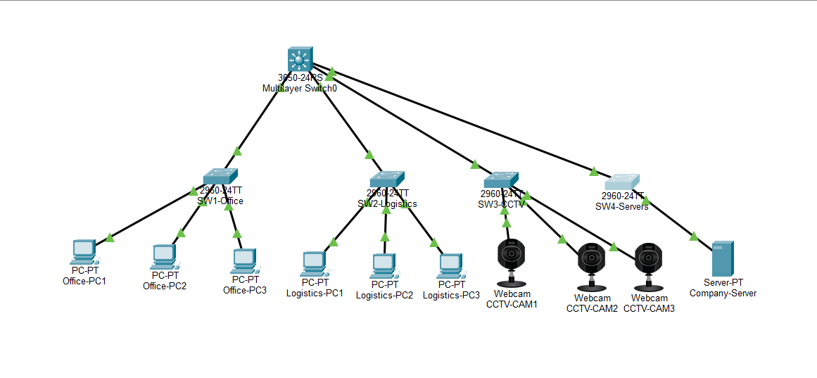
.

3. Core Switch Configuration Evidence
The Core Switch (CORE-SW) performs inter-VLAN routing for both IPv4 and IPv6 (ip routing and ipv6 unicast-routing enabled), with one SVI per VLAN carrying a dual-stack address.

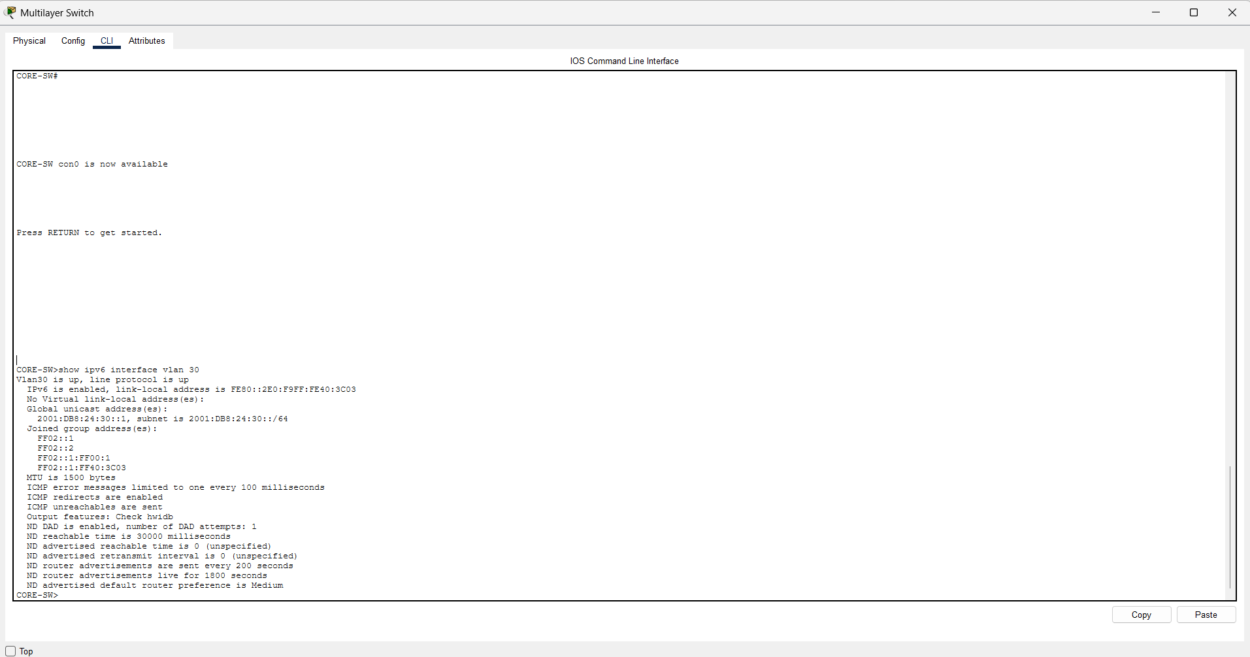
Figure 3: 'show ipv6 interface vlan 30' on CORE-SW — IPv6 gateway up/up.

4. Access Switch VLAN Confirmation
Each access switch carries its own VLAN on the access ports and trunks it back to the Core Switch.
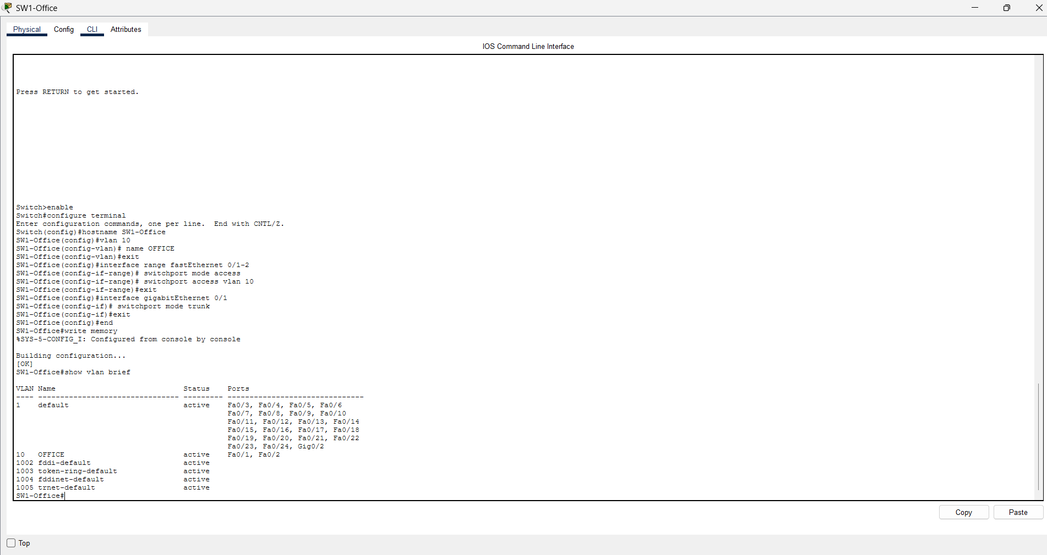
Figure 4: SW1-Office — 'show vlan brief', VLAN 10 active on Fa0/1, Fa0/2.
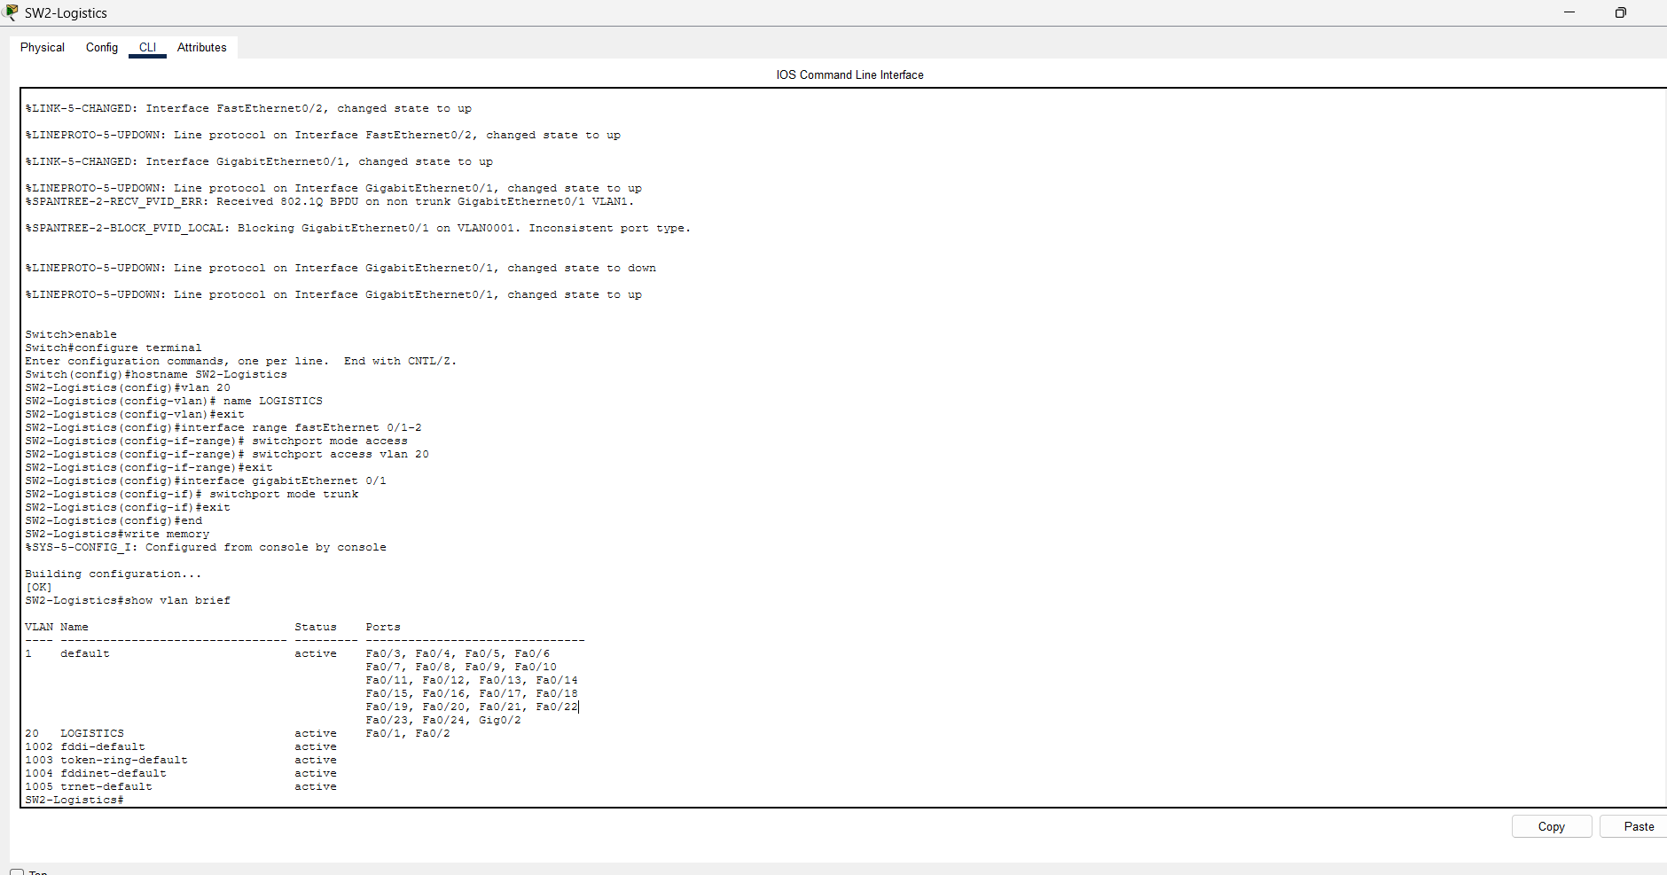
Figure 5: SW2-Logistics — 'show vlan brief', VLAN 20 active on Fa0/1, Fa0/2.
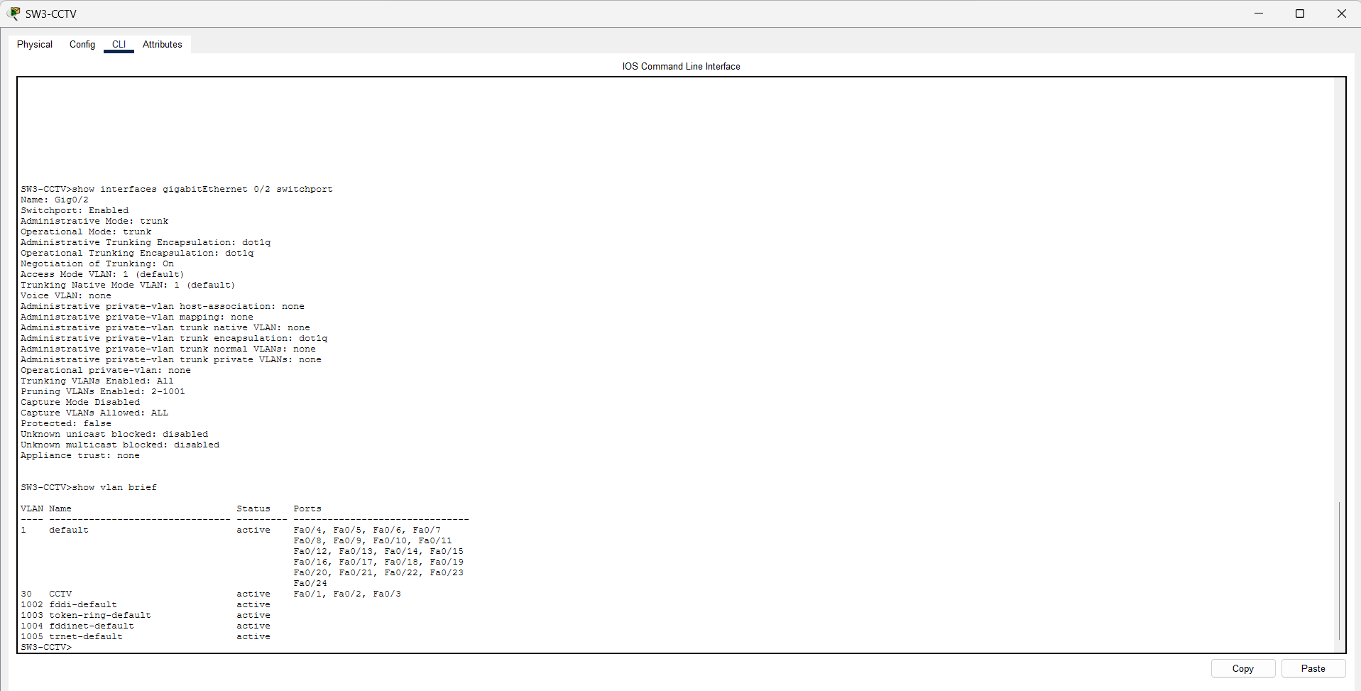
Figure 6: SW3-CCTV — trunk status (Gig0/2) and VLAN 30 active on Fa0/1-0/3.

5. End Device Dual-Stack Addressing
Representative samples of end-device IP Configuration, showing both IPv4 and IPv6 addresses set per the addressing plan.
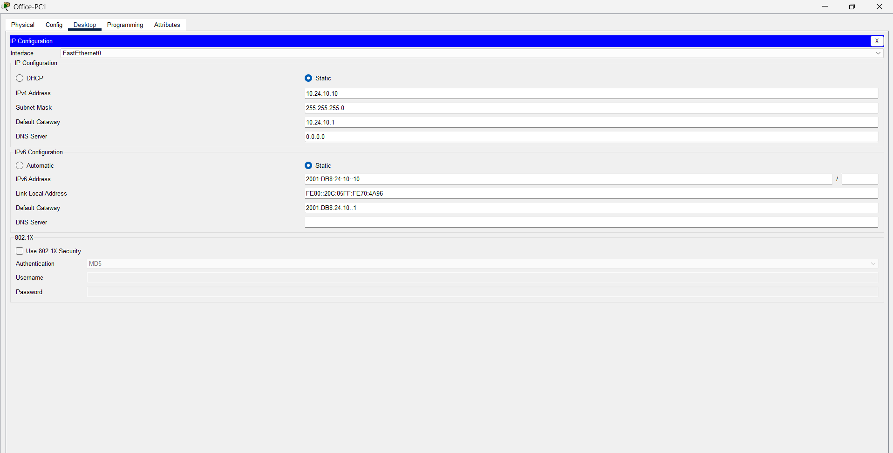
Figure 7: Office-PC1 — IPv4 10.24.10.10, IPv6 2001:DB8:24:10::10/64.
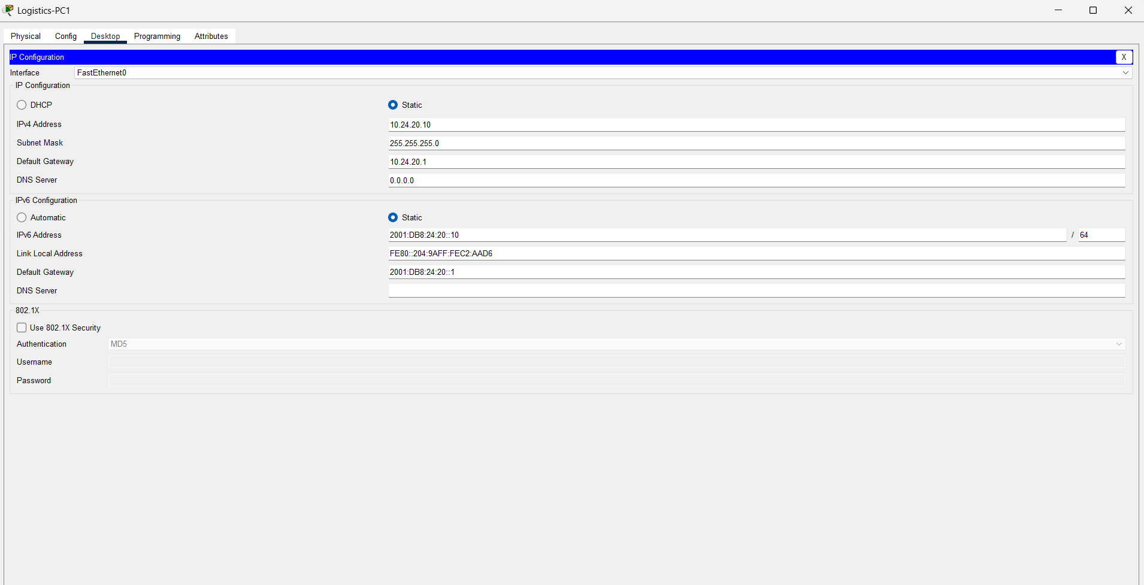
Figure 8: Logistics-PC1 — IPv4 10.24.20.10, IPv6 2001:DB8:24:20::10/64.
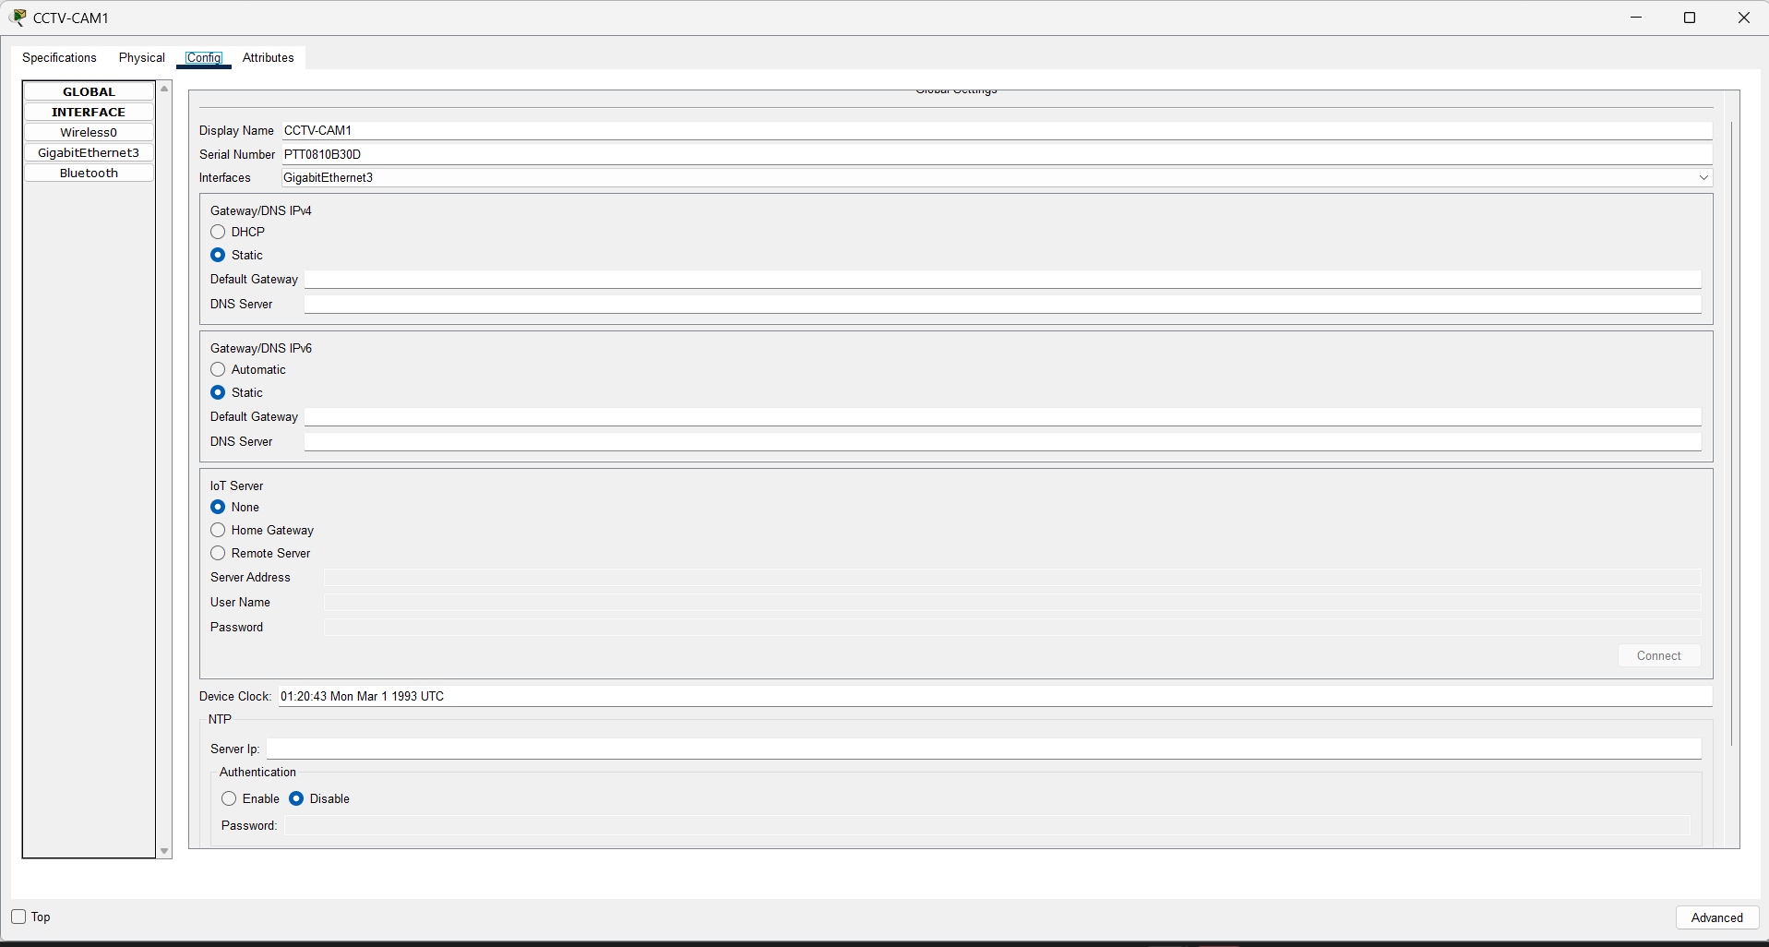
Figure 9: CCTV-CAM1 — GigabitEthernet3 interface, IPv4 10.24.30.10, IPv6 2001:DB8:24:30::10/64.
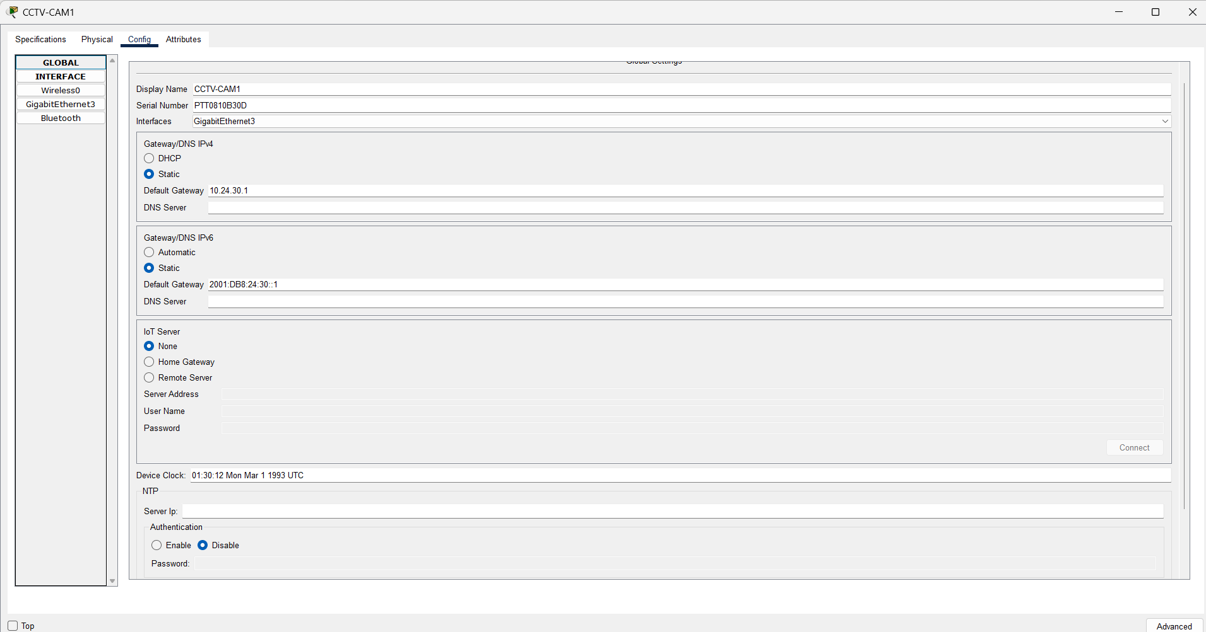
Figure 10: CCTV-CAM1 — Global gateway settings, IPv4 10.24.30.1, IPv6 2001:DB8:24:30::1.
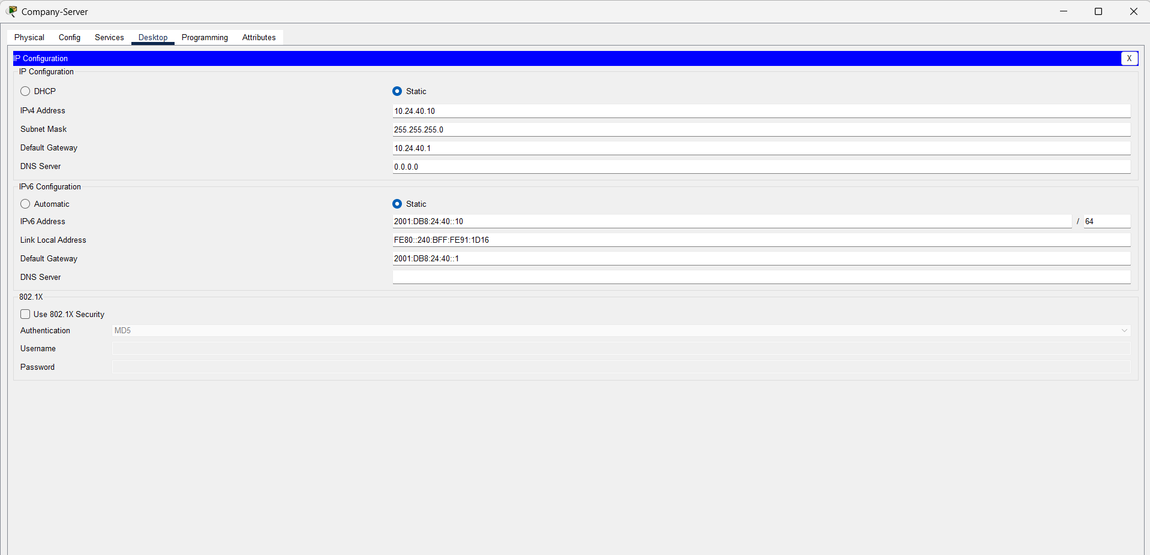
Figure 11: Company-Server — IPv4 10.24.40.10, IPv6 2001:DB8:24:40::10/64.

6. Connectivity Testing Evidence
Ping tests were run from Office-PC1 to verify both same-VLAN and cross-VLAN connectivity, across both IPv4 and IPv6.
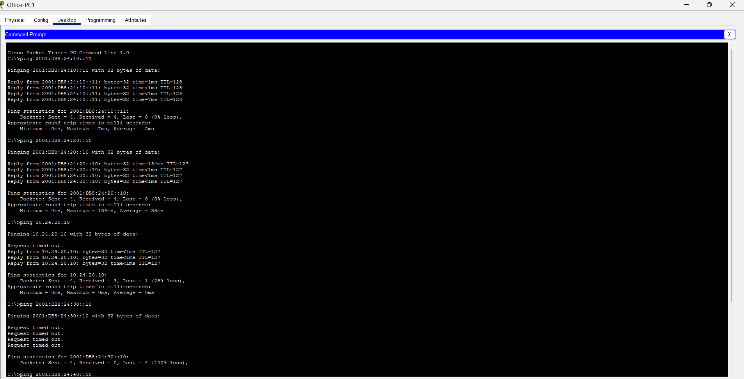
Figure 12: Office-PC1 Command Prompt — same-VLAN IPv6 (PC2), cross-VLAN IPv6 (Logistics-PC1), cross-VLAN IPv4 (Logistics-PC1), and the initial CCTV test (see Section 7).

Results summary
- Office-PC1 → Office-PC2 (same VLAN, IPv6): 4/4 packets received, 0% loss.
- Office-PC1 → Logistics-PC1 (cross-VLAN, IPv6): 4/4 packets received, 0% loss. Confirms IPv6 inter-VLAN routing on the Core Switch.
- Office-PC1 → Logistics-PC1 (cross-VLAN, IPv4): 3/4 received (first packet lost to ARP resolution, normal behaviour), then resolved.
- Office-PC1 → Company-Server (cross-VLAN, IPv6): 4/4 packets received, 0% loss.

7. Troubleshooting: CCTV VLAN Connectivity
An initial ping from Office-PC1 to CCTV-CAM1 over IPv6 failed completely. This was systematically diagnosed before being resolved.

Step 1 — Confirm the Core Switch IPv6 interface for VLAN 30
Result: Vlan30 up/up, 2001:DB8:24:30::1/64 correctly configured (see Figure 3).

Step 2 — Confirm the access switch trunk and VLAN assignment
Result: SW3-CCTV Gig0/2 trunk operational, VLAN 30 active with the camera's port correctly assigned (see Figure 6).

Step 3 — Retest after allowing Spanning Tree to converge
The initial failure was identified as a Spanning Tree Protocol forwarding delay — newly configured access ports take 15–30 seconds to move from blocking to forwarding. Retesting after this delay succeeded:
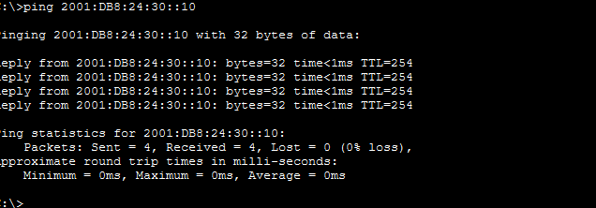
Figure 13: Office-PC1 → CCTV-CAM1 (IPv6) after STP convergence — 4/4 packets received, 0% loss.

Secondary issue — isolated IPv4 ping to CCTV-CAM1
A separate IPv4 ping from Office-PC1 to CCTV-CAM1 continued to time out despite the IPv6 path to the same device succeeding. This was investigated as follows:
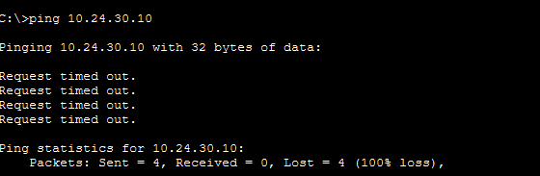
Figure 14: Office-PC1 → CCTV-CAM1 (IPv4) — request timed out, 100% loss.
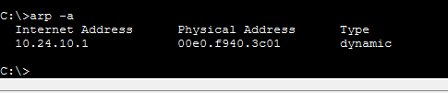
Figure 15: 'arp -a' on Office-PC1 — no ARP entry resolved for the CCTV-CAM1 address.
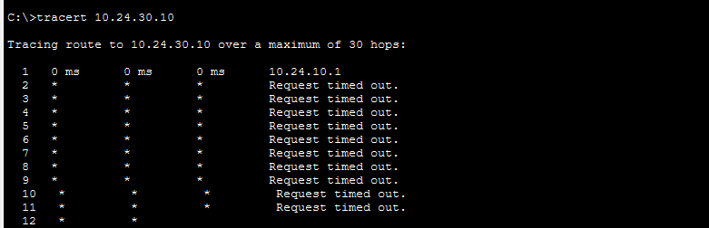
Figure 16: 'tracert' from Office-PC1 — only the first hop (default gateway) responded; later hops did not return ICMP TTL-exceeded replies, a known Packet Tracer simulation limitation for traceroute.
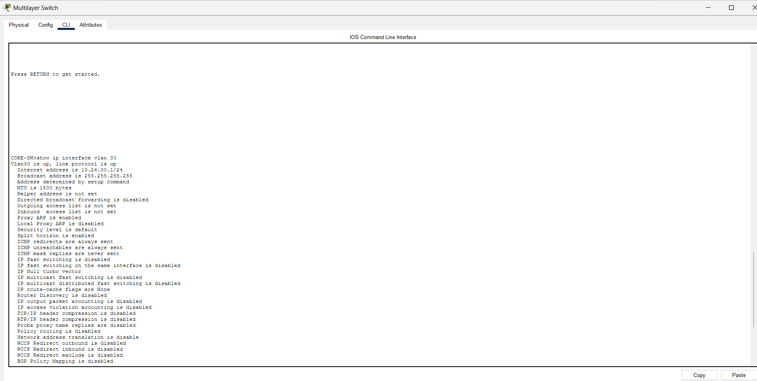
Figure 17: 'show ip route' on CORE-SW — 10.24.30.0/24 correctly listed as directly connected via Vlan30, alongside all other VLANs.
A direct ping issued from CORE-SW itself to CCTV-CAM1 succeeded 5/5 (100%), confirming the network path, routing table, trunk and switchport configuration were all functioning correctly end-to-end.
Conclusion: VLAN assignment, trunking, Core Switch routing (both IPv4 and IPv6) and the camera's own addressing were all independently verified as correct. The isolated IPv4 ping failure from one specific device (Office-PC1) to one specific device (CCTV-CAM1) is assessed as an ARP/simulation timing artifact within Packet Tracer rather than a configuration or design fault, since the identical IPv6 path and a same-network IPv4 ping from the Core Switch both succeeded.

8. Conclusion
The assigned networking challenge — IPv6 dual-stack addressing and routing — has been implemented and verified across all four VLANs (Office, Logistics, CCTV, Servers). Core Switch inter-VLAN routing, access switch trunking and VLAN assignment, and end-device dual-stack addressing were all configured according to the IP addressing plan and confirmed through direct testing. One isolated IPv4 connectivity issue was investigated methodically and traced to a simulation-specific artifact rather than a network fault. The completed Packet Tracer (.pkt) file accompanies this document and the project GitHub portfolio.

